**TRANSFERRING DATABASE FROM ON-PREM TO AWS SERVER**

**Step 1:-** Creating database to on-prem(on vmware)

- (steps to Install mariadb on server)

Yum install mariadb-server –y

Sytemctl start mariadb

Sytemctl enable mariadb

Mariadb_secure_installation

Mysql -u root –predhat

**Step 2:-** Setup in mariadb

Create database studentapp;

Show databases;

Use studentapp;

CREATE TABLE if not exists students(student_id INT NOT NULL AUTO_INCREMENT,

student_name VARCHAR(100) NOT NULL,

student_addr VARCHAR(100) NOT NULL,

student_age VARCHAR(3) NOT NULL,

student_qual VARCHAR(20) NOT NULL,

student_percent VARCHAR(10) NOT NULL,

student_year_passed VARCHAR(10) NOT NULL,

PRIMARY KEY (student_id)

);

Select * from students;

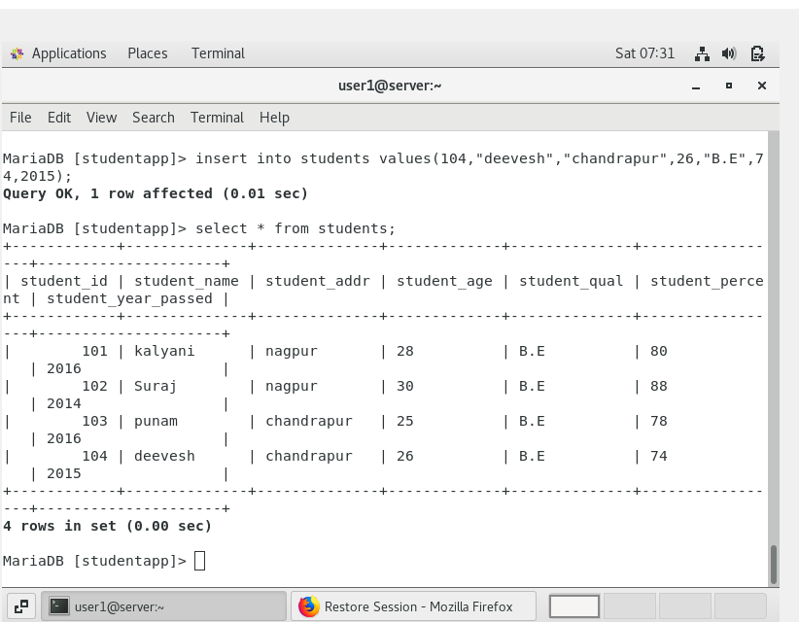

**Step 3:-** Take backup of the the file.

Mysqldump -u root –predhat studentapp > studentapbakup.sql

**Step 4:-** download filezilla app to transfer file from linux to windows.

-enter yor on-prem servers ip address, hostname, 22 port no. for ssh

-drag and drop backup file to window and with the help of “scp” command copy file from windows to ec2 database server.

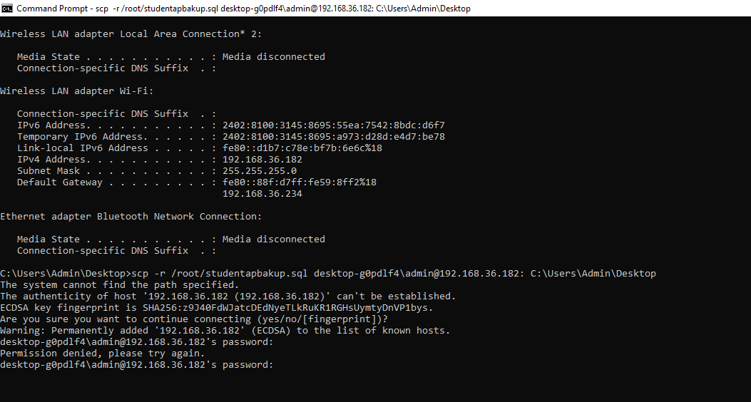

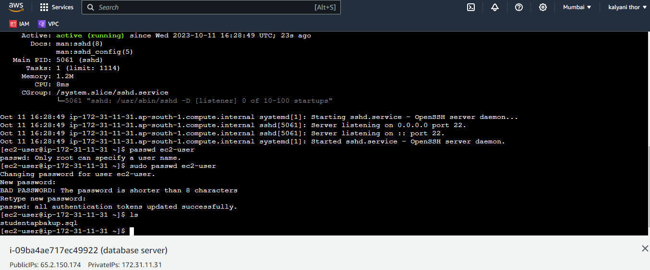

-By this way we have successfully transfer the on-prem data to ec2 database server.